**CREATING COLLECTION**

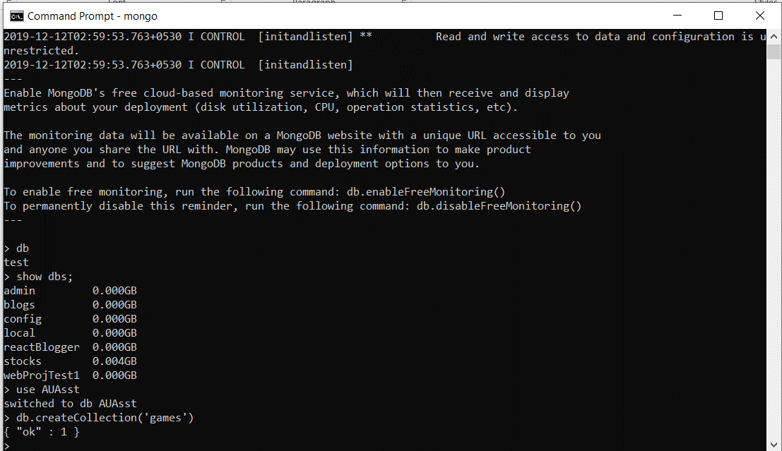

**ADDING 5 GAMES**



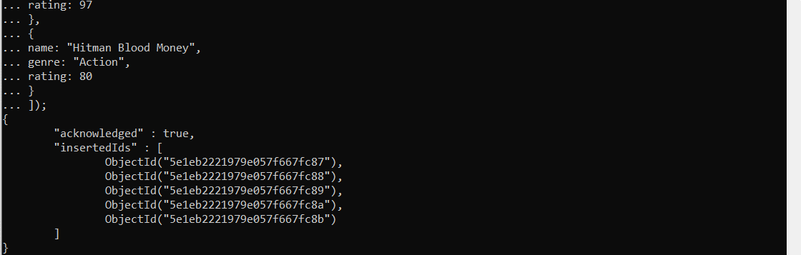

**QUERYING ALL GAMES**

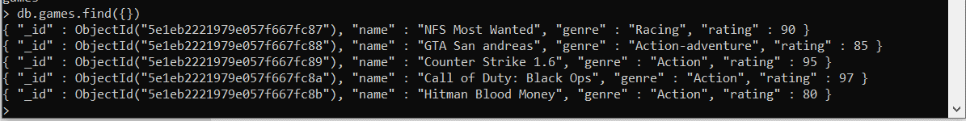

**FINDONE, LIMIT AND SORT**

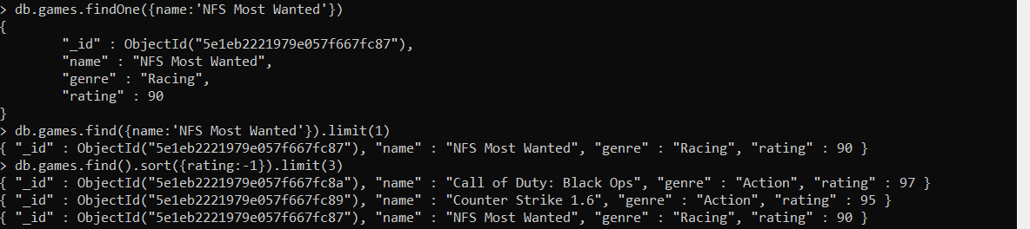

**UPDATE**

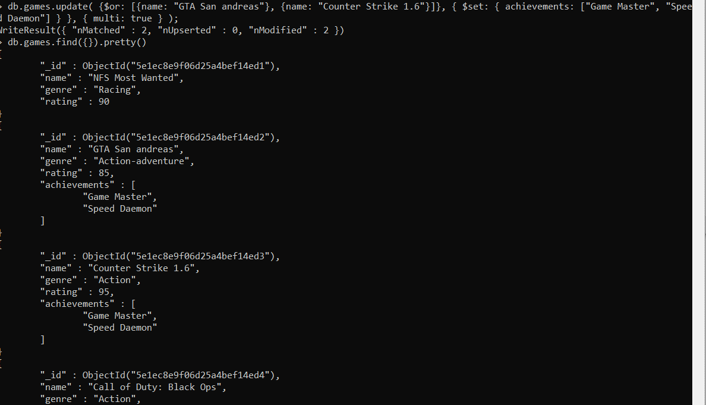

**FINDING GAMES HAVING BOTH GAME MASTER AND SPEED DAEMON**

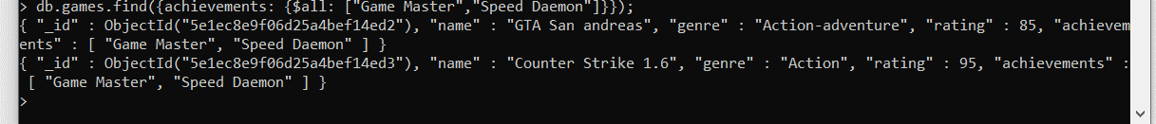

**FINDING GAMES WHICH HAVE ACHIEVEMENTS**

